**KATHMANDU UNIVERSITY**

**DHULIKHEL, NEPAL**

**Department of Computer Science & Engineering (DoCSE)**



**FINAL PROJECT REPORT**

**ON**

**“SMART WARD”**

**Submitted for the partial fulfillment of**

**The course COMP-206**

**Submitted By:**

**Shrawak Bhattarai (11)**

**Ramraj Chimouriya (13)**

**Deependra Kumar Gupta (18)**

**Shreyam Pokharel (40)**

**Computer Engineering**

**2nd Year, 1st Semester**

**Submitted To:**

**Mr. Nabin Ghimire**

**March 10, 2020**

**Bonafide Certificate**

**SECOND YEAR FIRST SEMESTER PROJECT REPORT**

**On**

**SMART WARD**

**Certified that this project report “SMART WARD” is the bona fide work of “Shrawak Bhattarai, Ramraj Chimouriya, Deependra Kumar Gupta, Shreyam Pokharel”, who carried out the project work under my supervision.**

**Project Supervisor**

**______________________________**

**Mr. Pratit Raj Giri**

**<Academic Designation>, Kathmandu University**

**Department of Computer Science and Engineering (DoCSE)**

# Acknowledgement

Our project “SMART WARD” would not have come this far without the invaluable contribution of 'Department of Computer Science and Engineering' who gave us the platform to explore new ideas and how to proceed further on our project.

We would like to express sincere gratitude to our project supervisor Mr. Pratit Raj Giri, who has directed the execution of tasks in the project in a sequential and in an efficient manner. We would also like to thank our seniors and friends who helped us to setup the basic ideas and features in this project.

We would again thank all those who have helped us in giving a small bit of assistance in our project.

# Abstract

A number of activities are carried out in ward offices. People reach ward offices of their respective municipalities for their work on a daily basis. Be it creating certificates for vital registration activities or receiving recommendation letters for citizenship, people need to reach the ward offices of their respective localities for these works. This project is a platform providing access to various activities that are carried out in these departments. Whether it is for storing records of a given ward or for planning of activities in that ward, this project aims to help in carrying out these activities with ease along with providing security while storing that information. It also aids in analyzing the data of a particular ward on the basis of different parameters and providing the various certificates associated with the works carried out there. It uses parameters such as days, months and years to analyze the data stored in the records. So, our project uses PyQt5 package for the user interface, Python for back-end coding and MySQL database to store the information, which can later be used to analyze and plan for different activities. Thus, our project is an integration of a platform for works carried out in ward offices in addition to being a platform for data visualization.

**Keywords:** PyQt5, Python, MySQL, Data Visualization

**TABLE OF CONTENT**

Acknowledgement i

Abstract ii

List of Figures iii

List of Abbreviations iv

Chapter 1: Introduction 1

1.1. Background 1

1.2. Objectives 2

1.3. Motivation and Significance 2

Chapter 2: Related Works/ Existing Works 3

Chapter 3: Design and Implementation 4

3.1. System Requirements Specification 5

3.1.1. Software Specification 5

3.1.2. Hardware Specification 5

Chapter 4: Discussion on the Achievements 6

Chapter 5: Conclusion and Recommendation 7

5.1. Limitations: 7

5.2. Future Enhancements 8

References 9

Bibliography 9

Appendices 10

# 

# List of Figures

Figure 1 Register Window 10

Figure 2 Main Window 10

Figure 3 Birth Registration Form 11

Figure 4 Birth Statistics Window 11

# List of Abbreviations

OS: Operating System

GUI: Graphical User Interface

PC: Personal Computer

IDE: Integrated Development Environment

UNICODE: Universal Coded Character Set

# 

# ****Chapter 1: Introduction****

The project is entitled “Smart Ward” and is aimed to help ward offices to keep records like vital registration details, provide recommendation letters for citizenship, copy of citizenships , income property evaluation among others along with providing the facility of data evaluation using data visualization.

## 1.1. Background

The process of keeping record of vital human activities dates back to a very long period. People have introduced various methods in an attempt to record these activities. These methods, in accordance with the conditions and time, have changed drastically through to the 21st century. Most of these activities took place with the help of paperwork while some have had the help of various modern techniques or so. Paperwork is considered to be one of the securest means of data protection, but having said that, the use of paperwork leads to a lot of confusion. It can be more vulnerable if not handled properly. So, completion of most of those activities is very messy and time consuming. Even though some departments use spreadsheet software for storing data, they are limited to a certain extent and also do not serve the purpose of what they are supposed to do. Hence, addressing these typical real-life problems in these departments, we decided to complete a project in a pursuit of helping them store and analyze data for future use.

Most of the ward offices in Nepal still use older techniques for handling and implementing these activities. There is no surety as to what time those activities can take place or to the security of the information. Many files are found missing in such departments which can compromise the peoples’ trust in those departments. With the advent of new techniques and modern software it can be easier to perform these activities easily and securely. But still those software have been able to perform limited work. So our project intends on getting all these activities at a common platform along with aiding for representation of the data which can be used for future planning and implementation.

## 1.2. Objectives

The main objectives of this project are:

▪ To provide a digitized platform for replacing paperwork on ward offices.

▪ To help the ward departments visualize the certain records on the basis of different parameters, through which they will be able to carry out different programs in an efficient way.

▪To improve the quality of the citizen service delivery system and offer these services with optimal effectiveness and transparency.

▪To allow data sharing across different departments, thus bringing about efficiency

in administration functioning.

▪To facilitate the decision-making process of top management by furnishing the right information at the right time.

## 1.3. Motivation and Significance

As we were assigned to develop a project as a part of our course and we kept on deciding on various topics as an idea for the project. We came up with three to four ideas which we were not satisfied with. We were researching contents on the internet when we came across an article on data visualization. So, we decided to give this idea a go. We now focus on implementing this concept in real time problems and with 6684 wards in Nepal, what is more important than software that could simplify paperwork in these wards.

Paperwork is difficult to store and maintain for future use. This software could easily handle problems of collecting and storing records, which makes it way easier to use it for future reference. Various graphs like bar graphs, scatter plot, histogram etc. make it easy to make annual reports for municipality as well for analyzing and comparing economic, social and geological status of ward with great accuracy.

# Chapter 2: Related Works/ Existing Works

There are various softwares used by different departments for performing different jobs. But the use of these softwares is either limited to just a few works or most of the software are not used in our area. There are some softwares offering similar facilities in India but at the municipality level. In the context of our country, we find softwares for ward functionalities which can keep a record of population on different basis in a digitized way but those softwares cannot visualize records and compare the number of records of that ward on a daily, monthly or yearly basis.

Selvan, T. (2014) designed an automated system for Municipal Corporation which used an E-based system to automate the related activities and store data.

Also, the Victoria Department of Justice and Community Safety use this sort of app for birth, death and Marriage registry.

Walker, C. (2015) designed a project “Gramps Genealogy Software” that aids in the birth, death and marriage registry and also in representing a family tree.

So, our project incorporates different aspects and ideas of the aforementioned softwares and projects to provide a common platform for these ward offices to carry out their work and not compromise the safety of the records that are handled out there. Also, we are implementing a new idea in our project that deals with data visualization which helps the departments analyze the records and perform their tasks accordingly.

# Chapter 3: Design and Implementation

Each one of us came up with an idea and we finalized the best one for the project. Then, in the group we discussed how the idea can be presented as the project. We also discussed different features that can be implemented in the project. Moreover, we also took ideas from our classmates regarding our project development.

## 3.1. System Requirements Specification

### 3.1.1. Software Specification

#### 3.1.1.1. Front End Tools

PyQt5

PyQt5 is a free and open source Python library/ package for developing GUI apps that provides various classes for creating a user interface. During this project, we considered using VS Code for editing and testing our codes.

#### 3.1.1.2. Back End Tools

Python3, MySQL, UNICODE

The backend of our project is the actual program containing libraries, functions, classes and other entities based on Python3. Subplot of Python library matplotlib is used for data visualization. These programs use variables and dictionaries that consume memory in RAM to make our website functional and responsive. The database will be managed using MySQL.

.

### 3.1.2. Hardware Specification

Our project is a simple application with some features resembling a management application, though sophisticated hardware is not required. Any modern PC capable of running a modern OS is sufficient to run the program smoothly.

# Chapter 4: Discussion on the Achievements

During our project, we came across several challenges. Primarily, we were totally unfamiliar with the Python programming language and the PyQt5 framework. We could not find any well documented resources regarding the use of PyQt5 on the internet. The video tutorials on the internet were not sufficient for us to solve our problems. Although our initial goal was to develop both a web and a desktop application, we were limited to making a desktop application due to lack of time.

The primary objective was to keep the records of birth, death, migration, divorce and different ward records, to visualize the records in different parameter, to give certificates of vital registration or recommendation letters to the concerned person and. However, due to lack of resources knowledge and time, we were only able to make a desktop application which can keep the ward records and visualize the data in different parameters.

**Features:**

After a ward department gets registered and logged in our system, main window can be accessed and records of birth, death, migration, divorce, marriage and many more ward works by taking the data of the concerned person can be stored in our local database. The registration can happen only once and after that whenever the application is run, the main window is directly accessed. Our project can visualize records and also can compare the number of records of that ward on a daily, monthly and yearly basis. Our application also allows the wards to change their profile which includes changing of their name, ward number and logo among others. Our application also provides certificates of the registered record to the concerned person.

# Chapter 5: Conclusion and Recommendation

Overall our group felt that we encompassed almost all the features we intended to add to our application. We also got a basic idea on how data can be stored in large amounts in the database and how we can access the data to use it for data visualization.

The major theme of our project was to create a platform for the application of basic works that a ward office conducts. Our project uses a simple database to store the data and extract the data for data visualization. Also the interface is quite easy for anyone to use without deep knowledge in data handling.

The project is an important part of learning the basics of application development and uses numerous features that can be implemented in the future. The knowledge and the concepts used in this project can be further applied in the future by making some modifications to these if required.

We are really very satisfied in the way we stuck to completing the elements of the project we intended to complete and also applied some ideas we received from by various individuals during the course of our project.

## 5.1. Limitations:

* This application is available to Windows/Linux users.
* This application can only access the local database and not the external servers for storing records.
* This application has typically an admin-based interface only.

## 5.2. Future Enhancements

* To make the application available in other operating systems, the same can be re-used and develop new programs with suitable compatibility.
* Using an online server for remote database access.
* A website version of this project can be added in order to increase the feasibility of the project as well as for a client-based interface.

# References

● Sparrow Job. (2019). *Ward Office Work Assigned*. [online] Available at: https://www.sparrowjob.com/ward-office-work-assigned/ [Accessed 11 Nov. 2019].

● Dia.govt.nz. (2019). *Births, Deaths, Marriages, Civil Unions, Name Changes, Passports and Citizenship Privacy Notice - dia.govt.nz*. [online] Available at: https://www.dia.govt.nz/diawebsite.nsf/wpg_URL/Legal-Privacy-Births-Deaths-Marriages-Civil-Unions-Name-Changes-Passports-and-Citizenship-Privacy-Notice?OpenDocument [Accessed 11 Nov. 2019].

● Introduction to Data Visualization in Python. (2019). Retrieved 11 November 2019, from https://towardsdatascience.com/introduction-to-data-visualization-in-python-89a54c97fbed

# Bibliography

● Matthes, E. (2015, November 20). Python Crash Course: A Hands-on, Project-based Introduction to Programming.

● Russell, J. (2010, April 13). Introduction to MySQL 5.5.

● Payne, B. (No Starch, 2015). Teach Your Kids to Code: A Parent-Friendly Guide to Python Programming.

# Appendices

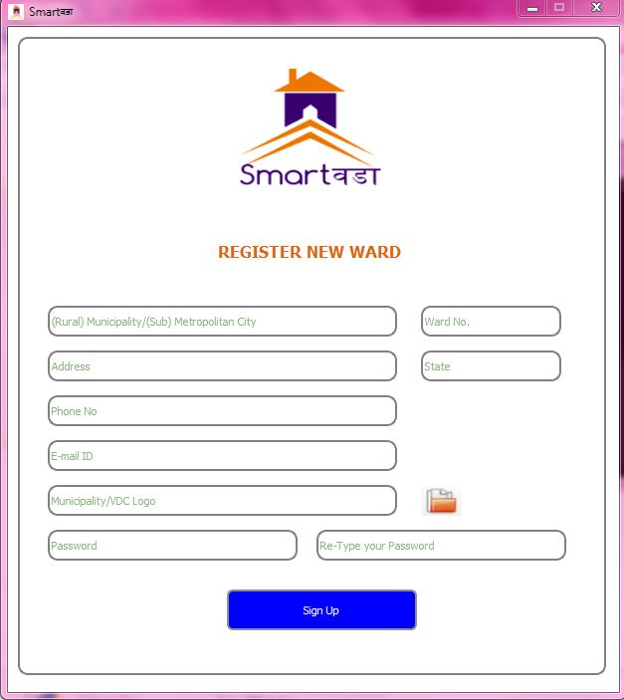

Figure 1 Register Window

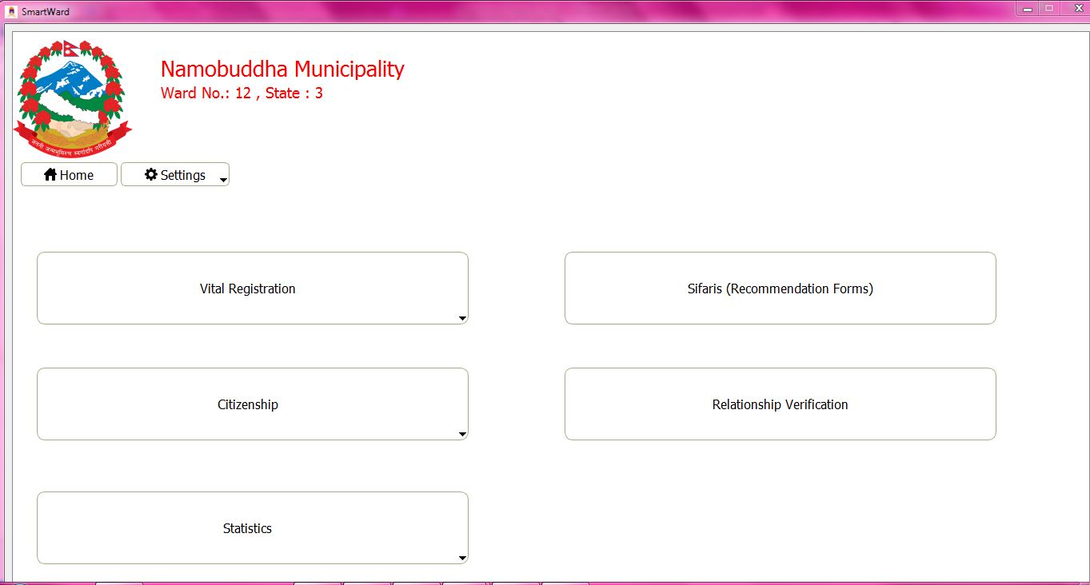

Figure 2 Main Window

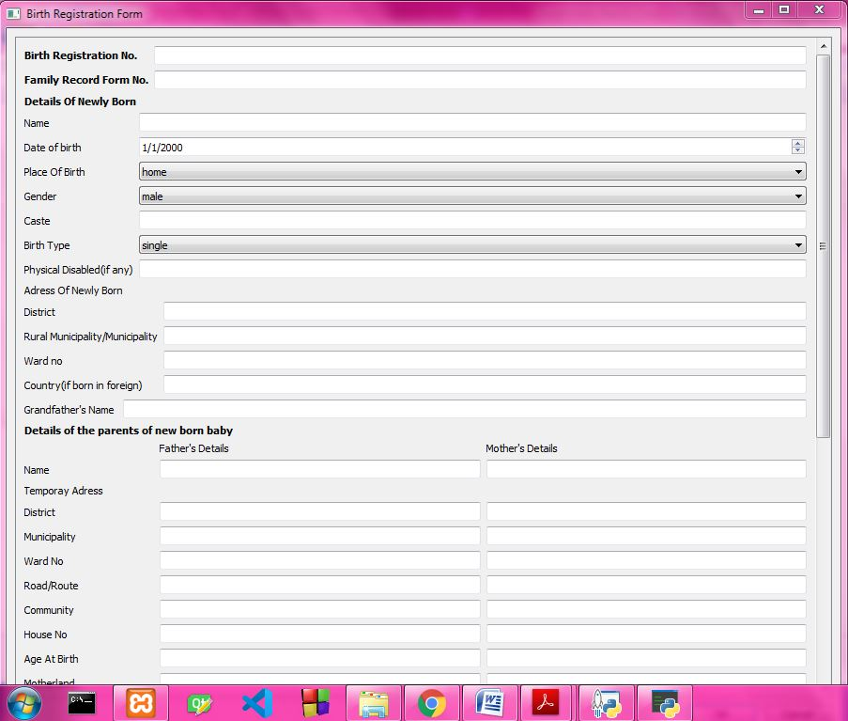

Figure 3 Birth Registration Form

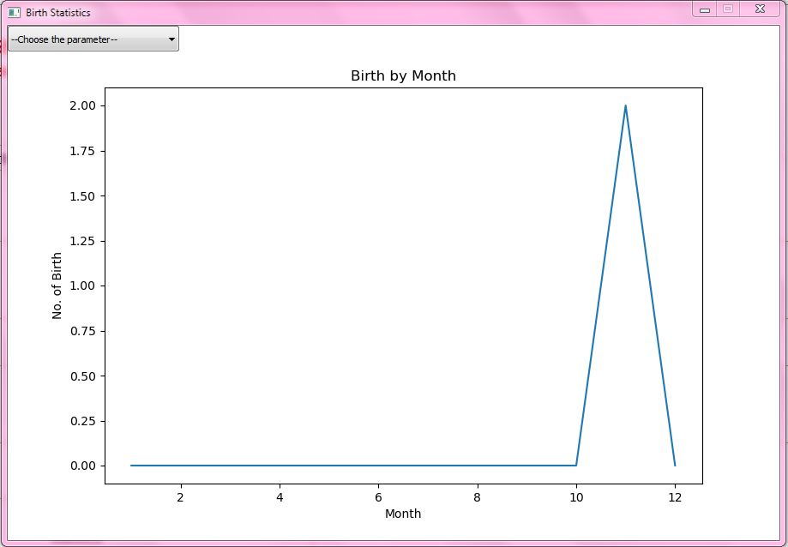

Figure 4 Birth Statistics Window